**KWAME NKRUMAH UNIVERSITY OF SCIENCE AND TECHNOLOGY**

**COLLEGE OF SCIENCE**

**FACULTY OF PHYSICAL AND COMPUTATIONAL SCIENCES**

**DEPARTMENT OF COMPUTER SCIENCE**



**MINIPROJECT DOCUMENATION**

Project Topic:

**Online Recharge System**

**APPLICATION DEVELOPED BY: AGYEPONG PATRICK FRIMPONG**

**INDEX NUMBER: 6844816**

**PROJECT SUPERVISOR: DR. FRIMPONG TWUM**

**Declaration**

I declare without reservation that I personally undertook the study herein submitted under supervision.

…………………………………… …………………………………

**DATE**  **AGYEPONG F. PATRICK**

I declare that I have supervised the student in undertaking the study submitte

d herein and confirm that the student has my permission to present it for assessment.

………………………………. ………………………………….

**DATE DR FRIMPONG TWUM**

**DEDICATION**

I dedicate this application to the Highest God who inspires to impact. I also dedicate it to the entire lecturers of the Computer Science department who have made a great impact in the study of Computer Science. Not forgetting my supervisor Dr. Frimpong Twum who took time from his busy schedule to give me advice on the project topic and contributed immensely to the development of the system.

This application is also dedicated to my parents who have greatly contributed to my education, Mr. and Mrs. Agyepong

And finally, it is dedicated to my learning group who motivated me in building such a project.

**ACKNOWLODGEMENT**

I am indebted to all who invested countless hours correcting and giving ideas to the content of this library.

My first acknowledgment goes to the Almighty God who makes great men out of little men, who inspired me from the day I decided to work on the application as my mini project work.

I would like to extend my gratitude to Dr. Frimpong Twum, my project supervisor who suggested better ideas to the application.

Finally, I would like to appreciate all the lectures of the department and to my family I would like to say my deepest gratitude goes to you.

Table of Contents

**CHAPTER ONE** 8

**INTRODUCTION** 8

**1.1 PROBLEM STATEMENT** 8

**1.2 SCOPE** 9

**1.3** **AIMS AND OBJECTIVES** 9

**1.4 SIGNIFICANCE** 9

**CHAPTER TWO** 10

**REVIEWS OF LITERATURE AND TOOLS** 10

**2.1 METHODOLOGY** 10

2.2 **REVIEW OF EXISTING SYSTEM** 10

**2.3 LIMITATION OF EXISTING SYSTEM** 10

**2.4 PROPOSED SYSTEM** 10

**2.5 FEATURES OF PROPOSED SYSTEM** 11

**CHAPTER THREE** 12

**REQUIREMENT SPECIFICATION** 12

**3.1 FUNCTIONAL REQUIREMENTS** 12

**3.2 NON-FUNCTIONAL REQUIREMENTS** 12

**3.3 ARCHITECTURE REVIEW** 13

**3.4 TECHNOLOGY REVIEW** 14

**3.5 HARDWARE REQUIREMENTS** 15

**3.6 SOFTWARE REQUIREMENTS** 15

**CHAPTER FOUR** 16

**SYSTEM ANALYSIS AND DESIGN** 16

**4.1 USE CASE DIAGRAM** 16

**4.2 ACTIVITY DIAGRAM** 17

**4.3 CLASS DIAGRAM** 18

**CHAPTER FIVE** 19

**DESIGN SPECIFICATION** 19

**5.1 Users of the System** 19

**5.2 Database Design** 19

**5.3 USER INTERFACE DESIGN** 20

**CHAPTER SIX** 29

**IMPLEMENTATION OF SOLUTION** 29

**6.1 SYSTEM TESTING** 29

**6.2 SYSTEM SECURITY** 30

**6.3 SYSTEM VALIDATION** 30

**6.4 CONCLUSION** 32

**6.5 APPENDICES** 33

**REFERENCES** 34

TABLE OF FIGURES

Figure 1 13

Figure 2 14

Figure 3 15

Figure 4 16

Figure 5 17

Figure 6 19

Figure 7 20

Figure 8 21

Figure 9 22

Figure 10 23

Figure 11 24

Figure 12 26

Figure 13 28

# **CHAPTER ONE**

## **INTRODUCTION**

### **1.1 PROBLEM STATEMENT**

As industries are fast expanding, people are seeking for more ways to purchase products with much ease and still maintain cost effectiveness. The vendors need to purchase the products in order to sell to end users. The manual method of going to their local recharge sales outlets to purchase data card is becoming obsolete and more tasking. You can recharge through the internet and payment made without going to the vendor or agent. So there is the need for a wide range of publicity and enabling direct order, processing and delivering recharges through online system. For this system, there will be a system administrator who will have the rights to change and correct plans as time goes on.

### **1.2 SCOPE**

This Online Recharge cater for people who have a stable connection to the website around the world.

### **1.3** **AIMS AND OBJECTIVES**

This study lays out a framework for a new system to be developed and brought to the market for maximum use and to create an avenue through the web where users can log on to our server and make a selection of whatever goods they like and subsequently pay via the internet. The following are the objectives this would bring:

1. The home page of this web interfile provides an avenue where customers will be able to gather more and reliable information about what the recharge system really does.
2. The products and services offered would provide the customers with all the different categories of available products that they can choose and select from.
3. This will provide a user-friendly environment between the customer and employee thus increasing the efficiency of the recharge system.

### **1.4 SIGNIFICANCE**

The Significance of this app is to help;

* Prevent people from having to go to stores in order to purchase a specific good.
* Making transaction of business on the internet as user friendly, safe convenient and easy as possible.

# **CHAPTER TWO**

## **REVIEWS OF LITERATURE AND TOOLS**

### **2.1 METHODOLOGY**

The Requirements for the building of the system was using “sublime”. The next stage was the developing stage where the coding and the design where also done using the sublime text editor and using google chrome to view the results this was used in the testing stage then to the implementation stage on completion of the system. The model used was the waterfall model because it is simple to use and understand, clearly defined stage and easy to arrange tasks.

The user interface was designed by using html alongside CSS with the JavaScript for interactivity. The html serves like the basic skeleton of the system while the CSS was used to beautify it and create a more professional outlook of the project. The JavaScript as stated above was used to provide the system with interactivity.

### 2.2 **REVIEW OF EXISTING SYSTEM**

Throughout the system analysis, an in-depth, study of end-user information is conducted, for producing functional requirement of the proposed system. Data about the existing online system is collected through several fact-finding techniques such as website visit and document review, at the beginning of this stage. The data collected facilities information required during detailed analysis. A study on the current system is performed based on the collected data. As a result, user requirement of the proposed system is determined. At the end of this stage, requirement specification is produced as deliverable.

**2.3 LIMITATION OF EXISTING SYSTEM**

With the current system sometimes security is a problem due to the sites been easily compromised by hackers. Also the goods sold may not be exactly what you ordered for due to the display of stock images therefore most sites depend on reputation for the site to be frequently accessed

### **2.4 PROPOSED SYSTEM**

This proposed system is that a website will now be provided so users can select what they want and pay for it via electronic payment without having to move from their respective homes or place of convenience

### **2.5 FEATURES OF PROPOSED SYSTEM**

* The User will login with a username, password in order to recharge.
* All information concerning users would be stored in the system.
* The database is a real time database.
* Users of the website will be able to pay for the goods via electronic payments.

# **CHAPTER THREE**

## **REQUIREMENT SPECIFICATION**

### **3.1 FUNCTIONAL REQUIREMENTS**

Functional requirements are the requirements of the system that describe the functionalities or services that the system is expected to provide to the users come what may.

* The User should be able to login with their username and password.
* The user should be able to select what to recharge and pay.

### **3.2 NON-FUNCTIONAL REQUIREMENTS**

Non-functional requirements are requirements that does not directly concern the functions performed by the application. The non-functional requirements include

* **Speed:** The website shall execute quickly including event response time (using the buttons).
* **User Friendly:** The system is designed in a user-friendly environment due to the user interface and the color scheme and the systematic arrangement of items in the said website.
* **Robustness:** The system is built in such a way that no one can inject any unwanted data or impose any threat on the system

### **3.3 ARCHITECTURE REVIEW**

Software architecture is a high-level structure of a software system. It is that level of abstraction that the system can be viewed as a whole. It is commonly defined in terms of components and connectors. The software architecture selected for this project is the 2- tier architecture. This architecture provides a greater application scalability, lower maintenance and increased re-use of components. It also provides for clean standardized interface between logical-component level called tiers. 2-tier architecture offers a technology neutral method of building client/server application. The 2-tier architecture isolates each major piece of functionality so that the presentation (user interface) is independent of database. This model requires much more analysis and design upfront but greatly reduces maintenance cost and increases functional flexibility in the long run.

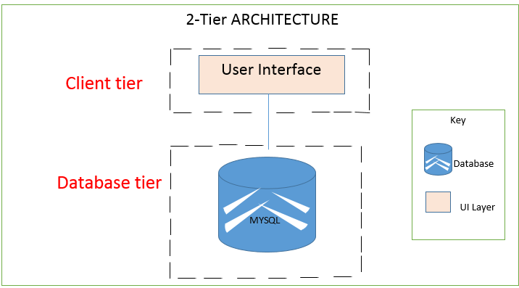

Figure 1

### **3.4 TECHNOLOGY REVIEW**

These include the programming languages and tools used to develop the software. The following below are the tools used in the designing the application:

1. HTML
2. JavaScript
3. MySQL
4. PHP

### **3.5 HARDWARE REQUIREMENTS**

The Host System should have a Server running.

### **3.6 SOFTWARE REQUIREMENTS**

The Online Recharge can work with any browser.

# 

# **CHAPTER FOUR**

## **SYSTEM ANALYSIS AND DESIGN**

### **4.1 USE CASE DIAGRAM**

Figure 2

Online Recharge



Administrator

### **4.2 ACTIVITY DIAGRAM**

Figure 3

User

Send error message

Invalid credentials

Valid Credentials

Valid add, update, deletion

Login

cv

id

Display Error Message

Delete Information

Update Information

Add Information

**dddca**

**4.3 CLASS DIAGRAM**

Database

### **4.3 CLASS DIAGRAM**

Figure 4

1 1

**Personal Details**

-User Name

-Contact Details

-Total fixes

**User**

-Email

-Password

Add, update, delete

**Each member**

-Unique code

View View

**Website**

-Users

# **CHAPTER FIVE**

## **DESIGN SPECIFICATION**

### **5.1 Users of the System**

­This website does not require a person to be highly trained in technology before he can use it. It only requires a person who can read and write so that he can follow the labels written on the various buttons, tabs, labels, combo boxes menu bars and the like.

### **5.2 Database Design**

The tables below show the conceptual database schema designed showing the various information used in the operation of the system.

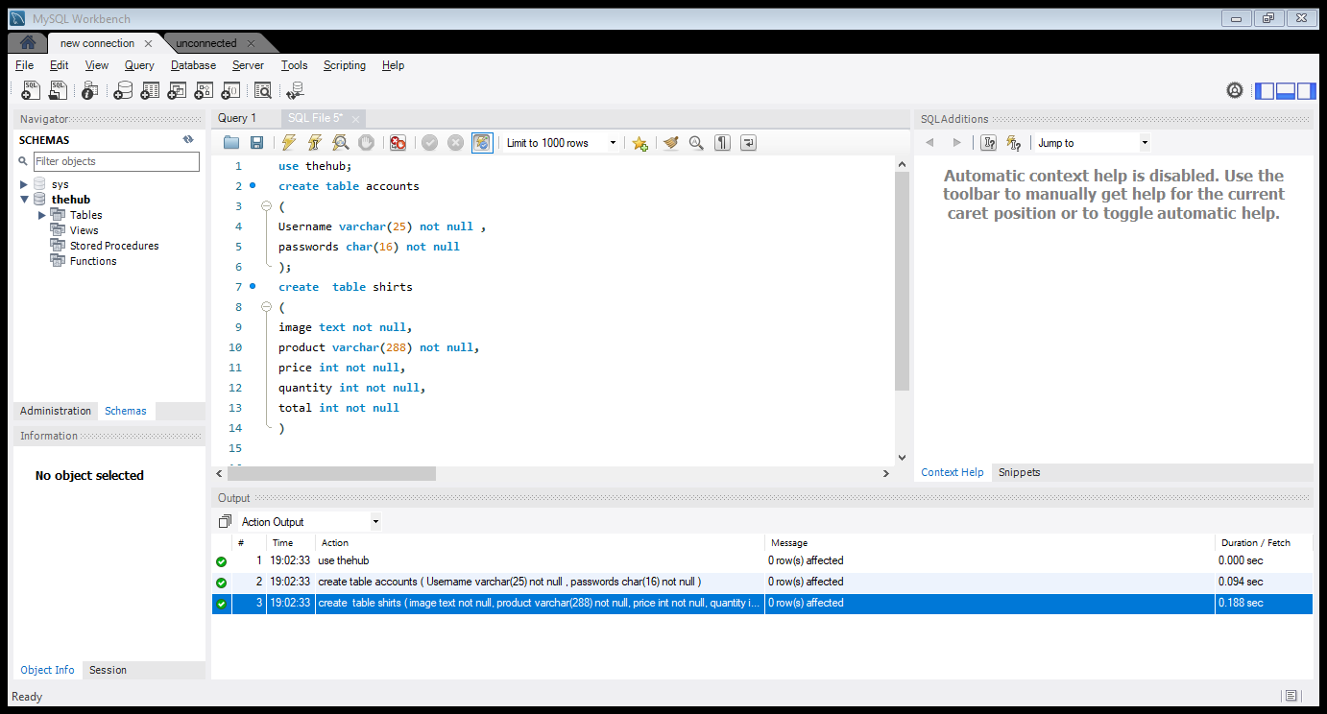

Figure 5

From the above image showing the database, every new user whether customer or driver registers for the app stores inside the database at once because it’s a real time database.

### **5.3 USER INTERFACE DESIGN**

**FOR THE ONLINE RECHARGE SYSTEM**

The Website is very basic and easy to use as long as one does not have difficulty reading.

The Figure below shows the first image of the website.

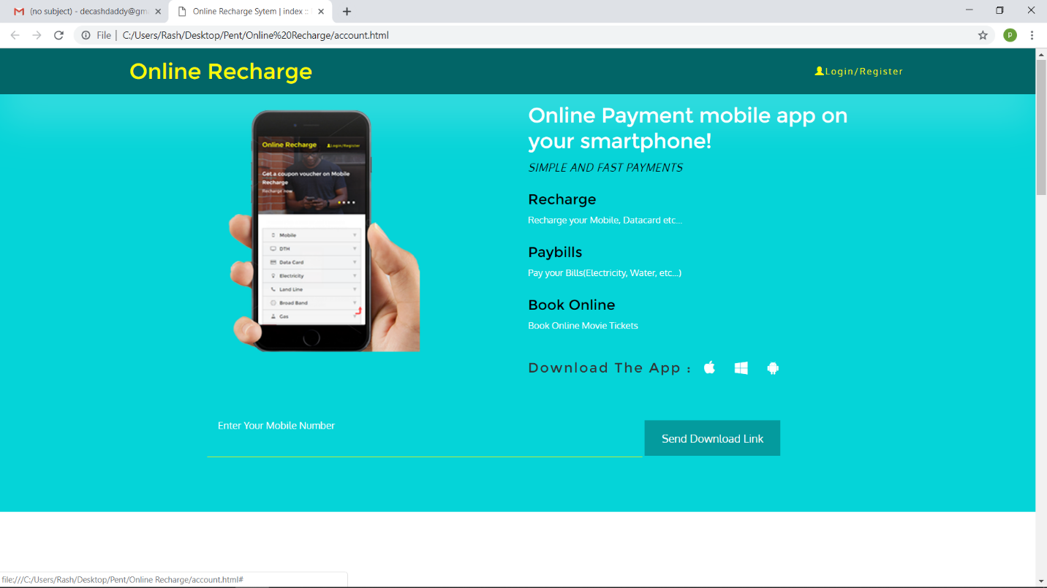

Figure 6

In the above interface the clicks on log in and user logs in using his email and password.

The Figure below shows the login interface of the user.

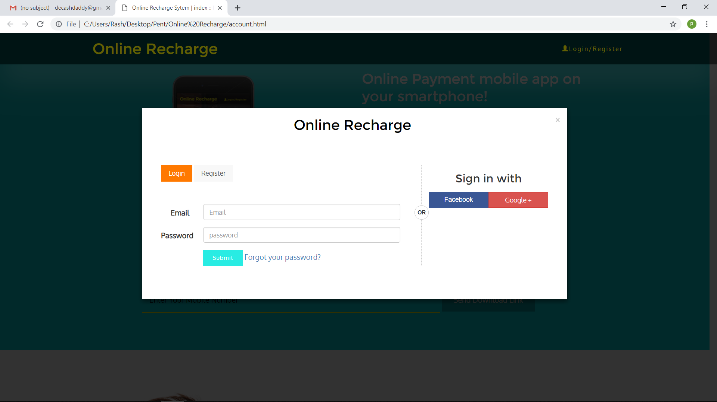

Figure 7

The Figure below shows the registration interface of the website

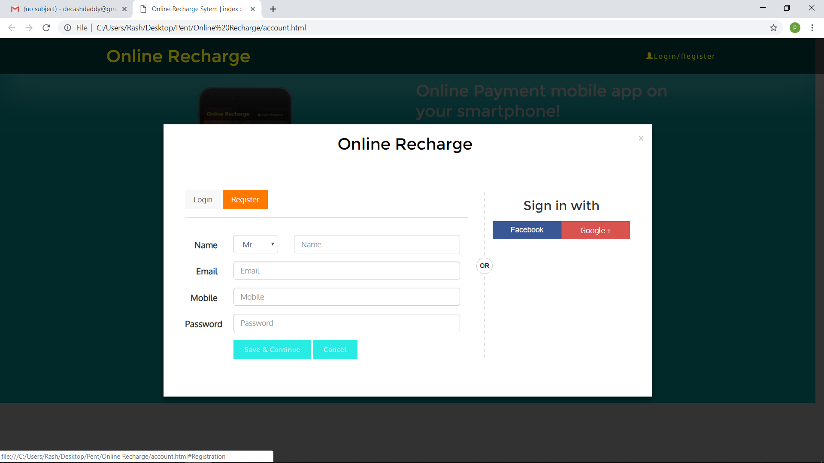

Figure 8

The Figure below shows what is displayed when the user logged in

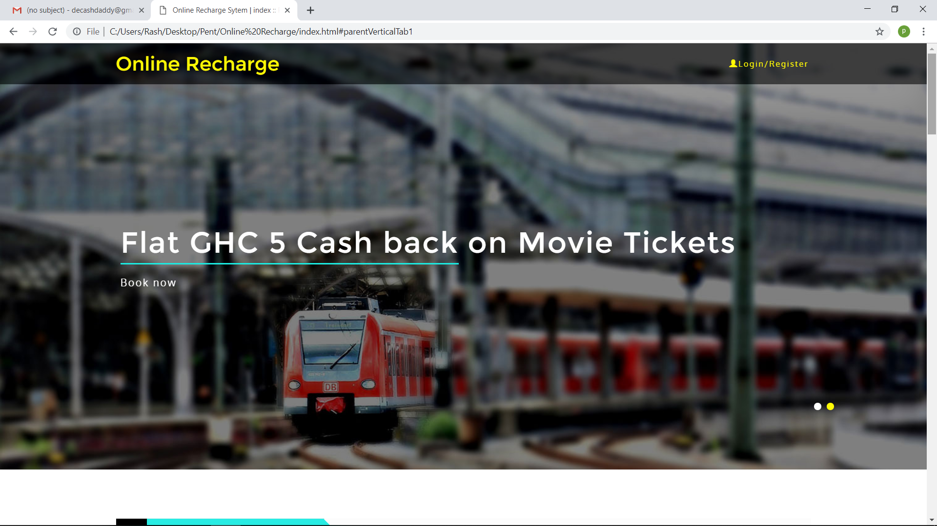

Figure 9

The Figure is displayed when a user wants to recharge.

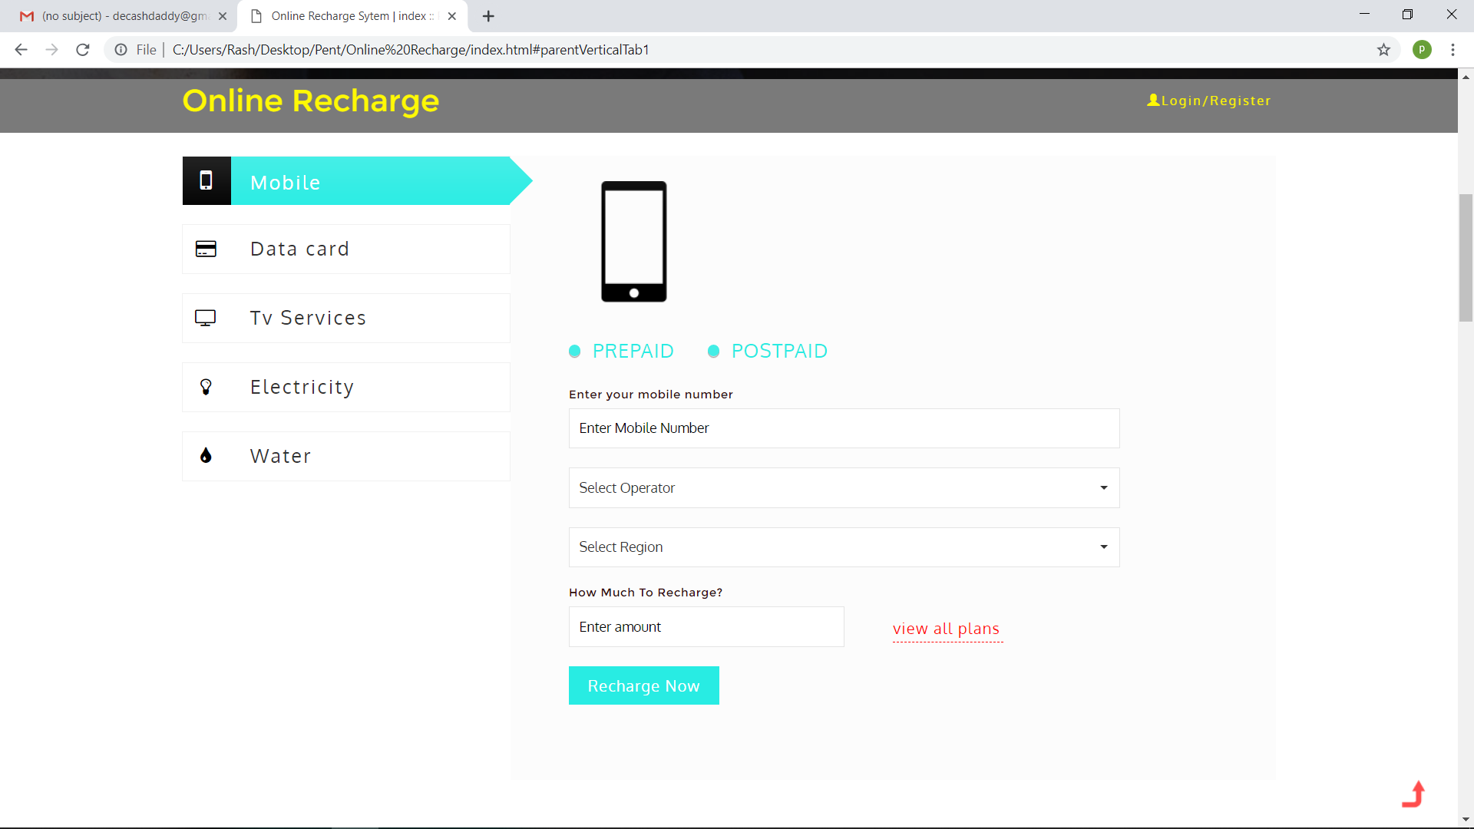

Figure 10

The Figure below displays when the user wants to pay with credit card

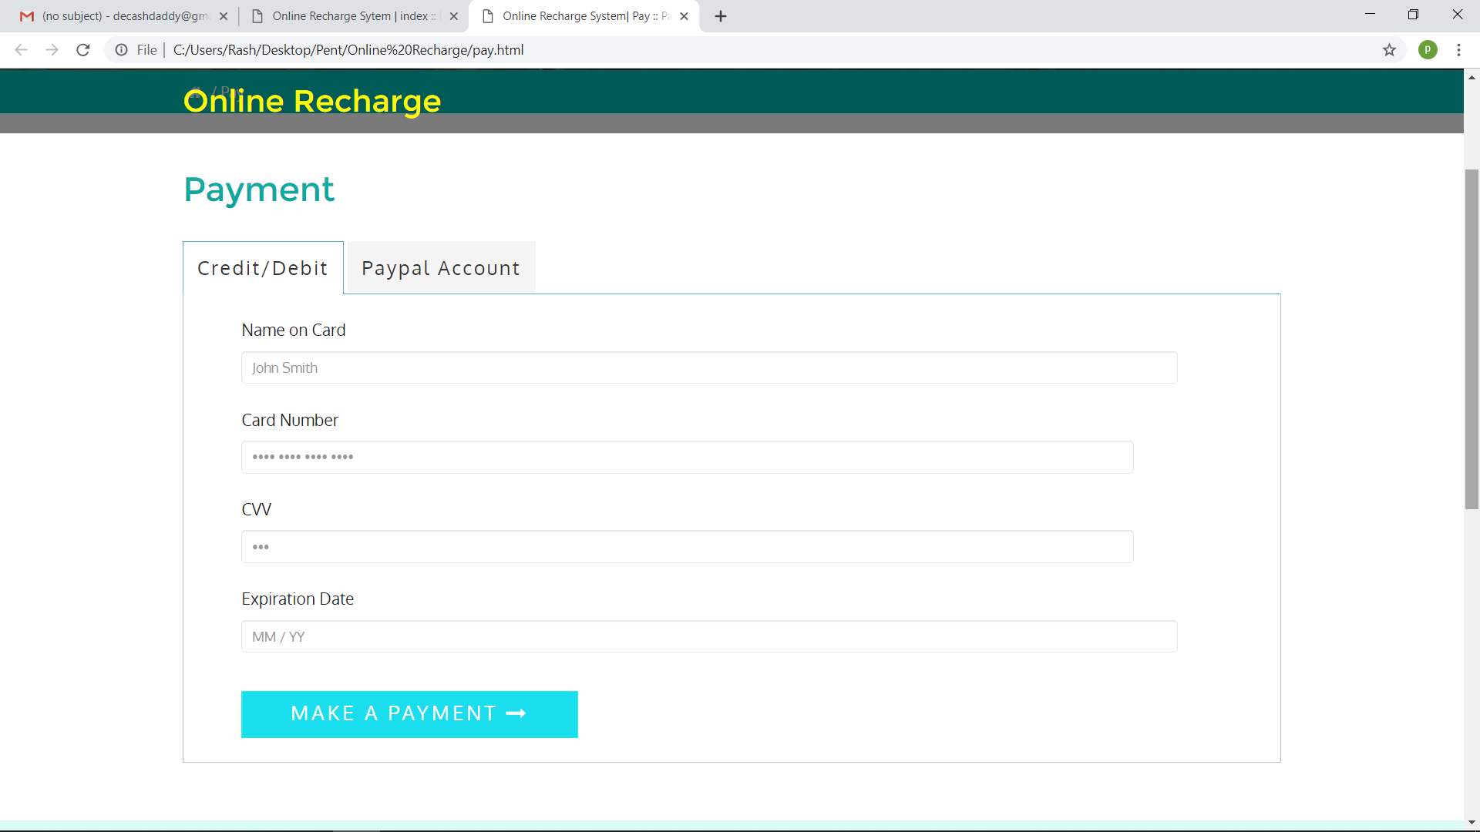

Figure 11

The Figure below displays when the user wants to pay via PayPal

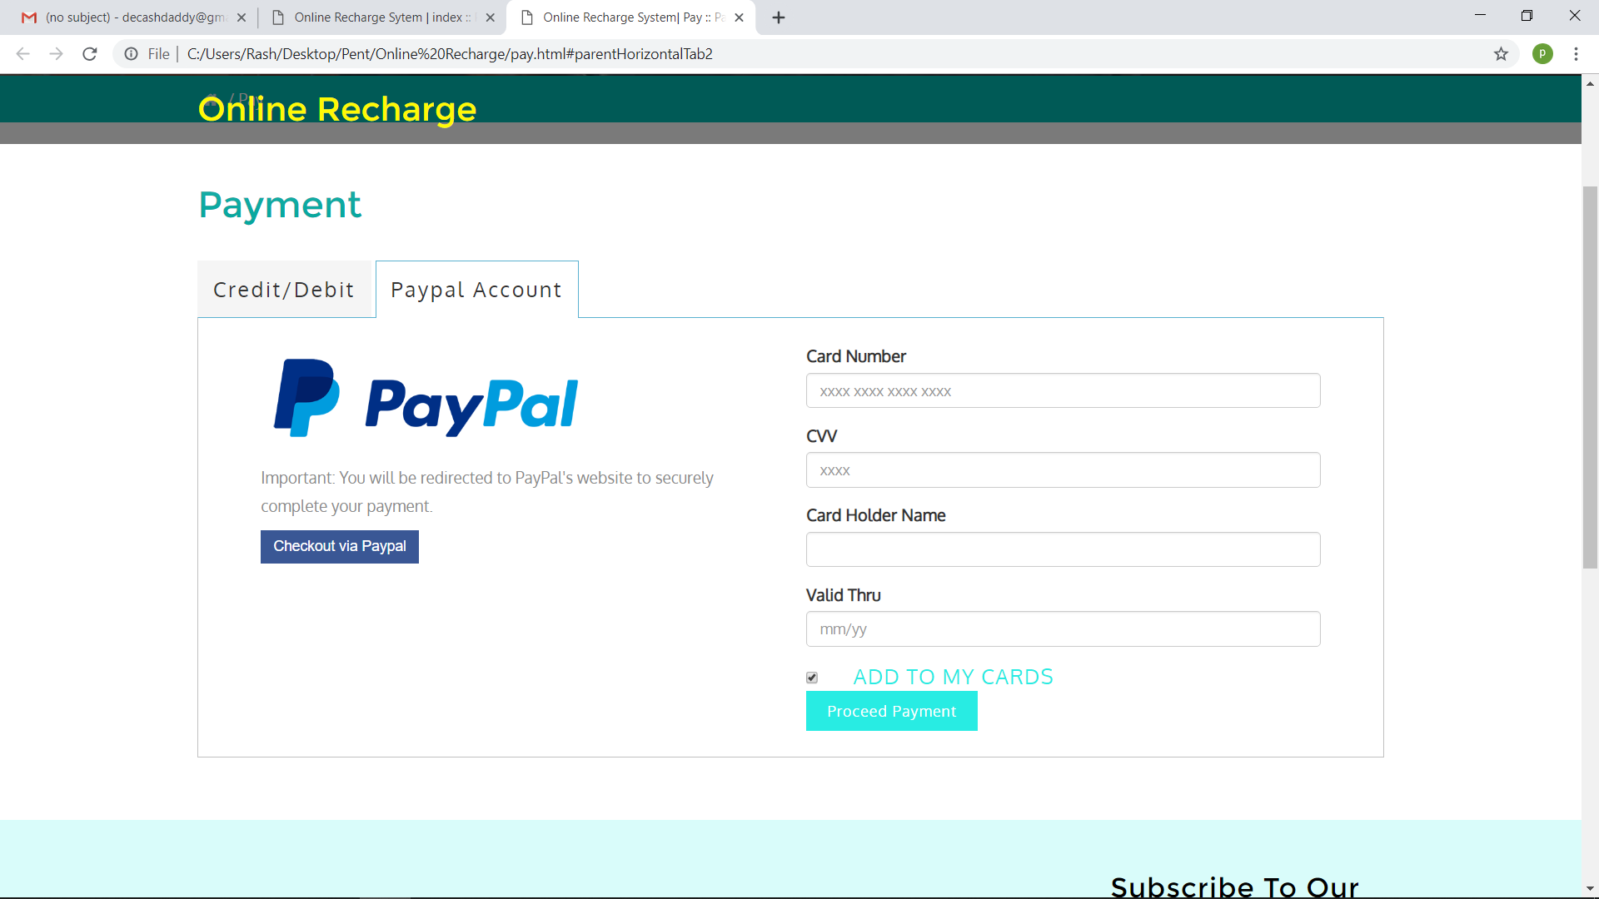

Figure 12

# **CHAPTER SIX**

## **IMPLEMENTATION OF SOLUTION**

### **6.1 SYSTEM TESTING**

Testing can be defined as the process of executing a program with the intent of finding errors. The main purpose of testing is to prove that the software works correctly and to ensure the system specification in software has been met. There are various testing strategies that can be used to prove that software meets its specification. For the purpose of this project, black box testing and the white box testing strategies were used

With the black box testing, after completion of the project, I invited some course mates to come and try the system out. This formed part of the system testing process. The purpose of this testing was to ensure that the software performs all the functions that were specified during the requirement specification stage.

White box testing was also done to ensure the logic of the software programs worked out correctly. This was done during the coding process and each module of the program to see how the website works and what action can be taken under any circumstance.

### **6.2 SYSTEM SECURITY**

This website provides a high quality and robust security to institutions because only the administrator has access to the main database.

### **6.3 SYSTEM VALIDATION**

The picture below when the wrong credentials are used a message is displayed at the bottom of the page p until the right credentials are entered before the homepage is displayed.

Figure 13

### **6.4 CONCLUSION**

In conclusion I believe all aims of the project where met and therefore it has been successful. Buying goods of the internet have been made easy and convenient using this website. The purpose for which the system was created has been met and has been presented in a simple user-friendly interface on both sides, that is the administrator and the user side. While developing this project I have learnt a lot as much research was done to solve problem and implement different functions, improving and adding to my knowledge in programming and also how to solve problems using this knowledge. I also learnt how to work to according to a time schedule as I was expected to produce something meaningful within a given time frame.

I am grateful for this opportunity to show what I’ve learnt so far and how well I can utilize and implement it.

### **6.5 APPENDICES**

HTML – Hypertext Markup Language

CSS-Cascading Style Sheets

UI- User Interface

PHP- Hypertext Preprocessor.

# **REFERENCES**

* W3schools.HTML Forms. <https://www.w3schools.com/html/html_forms.asp>
* Welling, L. and Thomsom, L., 2003*. PHP and MySQL WEB Development* 2nded. 201 West 103rd Street, Indianapolis, Indiana 46290: Sams Publishing.